Prerequirments
→ Check the Ram (free -m)
→ Check CPU (cat /proc/cpuinfo)
→ Check OS (uName)
Installation
3 Instance creation
1 Master → Java+Jenkins.
2 Slave 1 → Java.
3 Slave 2 → Java.
Configure 2 slave machines in the Jenkins master.
This guide documents the end-to-end configuration for establishing a multi-node Jenkins setup consisting of one Controller (Master) and two Linux Agents (Slaves) on Amazon Linux 2023.
1. Architecture Overview & Core Decisions
Host Role | Host Private IP | Installed Software
Jenkins Master (Controller) | 172.31.34-160 | OpenJDK 21+ Jenkins Core Application
Jenkins Slave 1 (Agent 1) | 172.31.42.187 | OpenJDK 21 Runtime only
Jenkins Slave 2 (Agent 2) | 172.31.37.71 | OpenJDK 21 Runtime only
Why Only Java on the Slaves (No Jenkins Package)?
->The Jenkins application runs solely on the controller.
->When the Master initiates an SSH connection to an agent, it transfers and runs a ->lightweight Java client (remoting.jar / agent.jar) directly in memory.
->The agent requires only the Java Virtual Machine (JVM) runtime to execute this ->binary, parse instructions, and stream logs back to the Master. Installing the full.
->Jenkins package on agents is unnecessary and consumes unneeded resources.
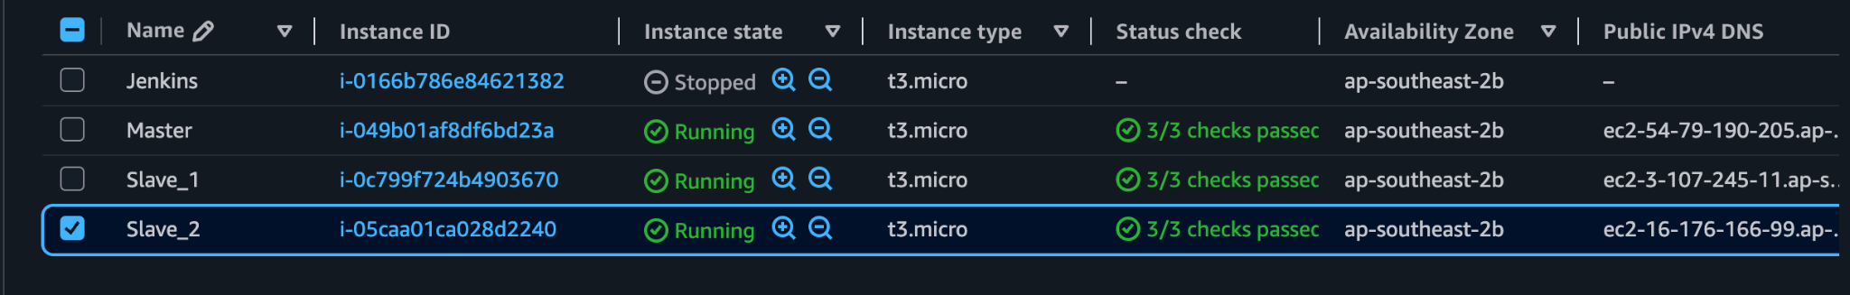
Master-EC2
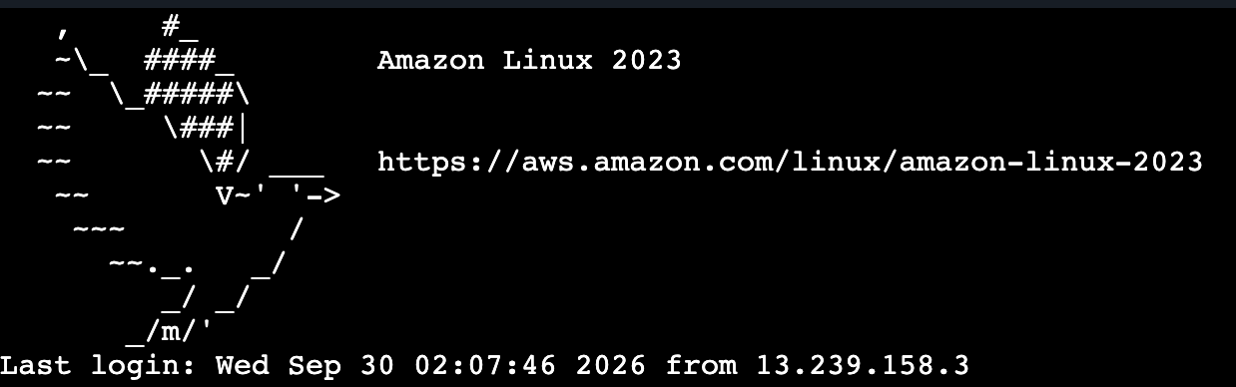
Install Updates:
# Update local repository indexes and packages
sudo dnf update -y.

# Install OpenJDK 21 Amazon Corretto
sudo dnf install java-21-amazon-corretto -y.

# Verify Java is available
java - -version.

# Download the official Jenkins Red Hat repository configuration file
sudo wget -O /etc/yum.repos.d/jenkins.repo https://pkg.jenkins.io/redhat-stable/jenkins.repo

# Import the official Jenkins GPG key to verify package integrity
sudo rpm --import https://pkg.jenkins.io/redhat-stable/jenkins.io-2023.key

3. Install, Enable, and Start Jenkins Service
# Install Jenkins package via dnf
sudo dnf install jenkins -y

# Reload systemd daemon to register the new Jenkins unit file
sudo systemctl daemon-reload

# Start the Jenkins service immediately and enable it to start across reboot
sudo systemctl enable --now jenkins

# Confirm the service status is active (running)
sudo systemctl status jenkins
4. Configure jenkins System User Shell
By default, the installer creates the jenkins user with /bin/false or /sbin/nologin for security. Change its default shell to /bin/bash so it can execute SSH sessions to the agents:
# Set bash as the login shell for jenkins
sudo usermod -s /bin/bash jenkins

# Verify the shell assignment
grep jenkins /etc/passwd
5. Generate Controller SSH Keys for Agent Authentication
Now switch cleanly to the jenkins user to generate the ed25519 key pair:
# Switch session to the jenkins user
sudo su - jenkins

# Move directly to the Jenkins service home directory
cd /var/lib/jenkins

# Create the SSH storage folder and lock down folder permissions
mkdir -p ~/.ssh
chmod 700 ~/.ssh

# Generate the ed25519 SSH key pair without a passphrase
ssh-keygen -t ed25519 -f ~/.ssh/id_ed25519 -N ""

# Output the public key (Copy this string for Slave 1 and Slave 2 authorized_keys)
cat ~/.ssh/id_ed25519.pub[span_11](start_span)[span_11](end_span)

6. Slave Node Configuration (Run on Slave 1 & Slave 2)
Perform these steps on both Slave 1 (172.31.42.187) and Slave 2 (172.31.37.71) logged in as ec2-user with sudo permissions:
1. Install Java 21 Runtime
Jenkins agents only need Java to execute tasks dispatched by the controller:
# Update repository packages
sudo dnf update -y.
# Install OpenJDK 21 Amazon Corretto
sudo dnf install java-21-amazon-corretto -y.
Slave_2
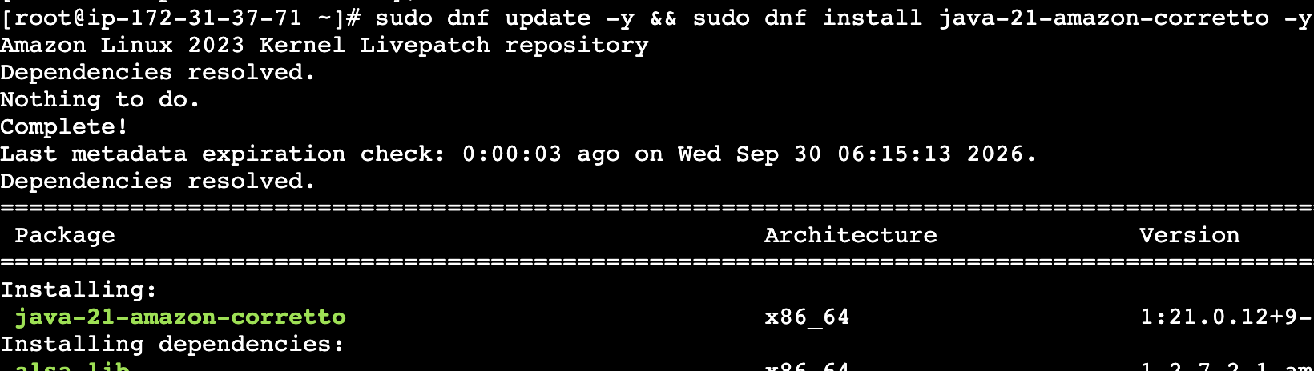
# Confirm Java is properly installed
java -version.
Slave_1
Slave_2
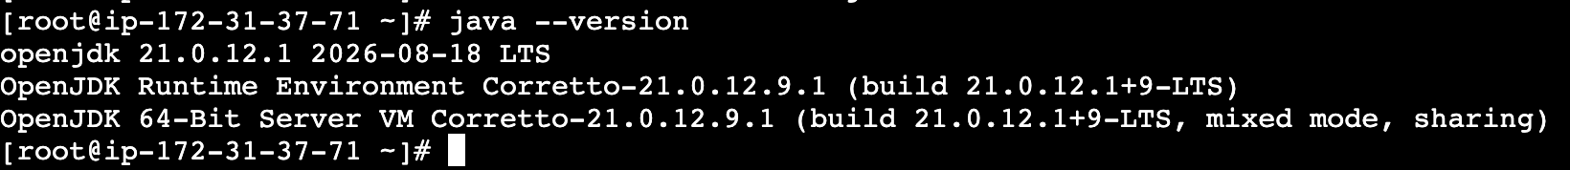
7. Create the Dedicated jenkins System User
# Create user with a dedicated home directory (-m) and bash shell (-s)
sudo useradd -m -s /bin/bash jenkins
# Create SSH directory
sudo mkdir -p /home/jenkins/.ssh.
# Paste the identical public key
echo "ssh-ed25519 AAAAC3NzaC1lZDI1NTE5AAAAIAC1ZZprtOFDG5YXsvm8NMh9GQi6kv3JbJTSGwoQapRQ jenkins@ip-172-31-34-160" | sudo tee /home/jenkins/.ssh/authorized_keys.
# Apply permissions
sudo chown -R jenkins:jenkins /home/jenkins
sudo chmod 755 /home/jenkins
sudo chmod 700 /home/jenkins/.ssh
sudo chmod 600 /home/jenkins/.ssh/authorized_keys

Test SSH Connectivity from Master
Go to your Master terminal (where you are logged in as jenkins) and run:
# Test connection to Slave 1:
ssh -i ~/.ssh/id_ed25519 jenkins@172.31.42.187
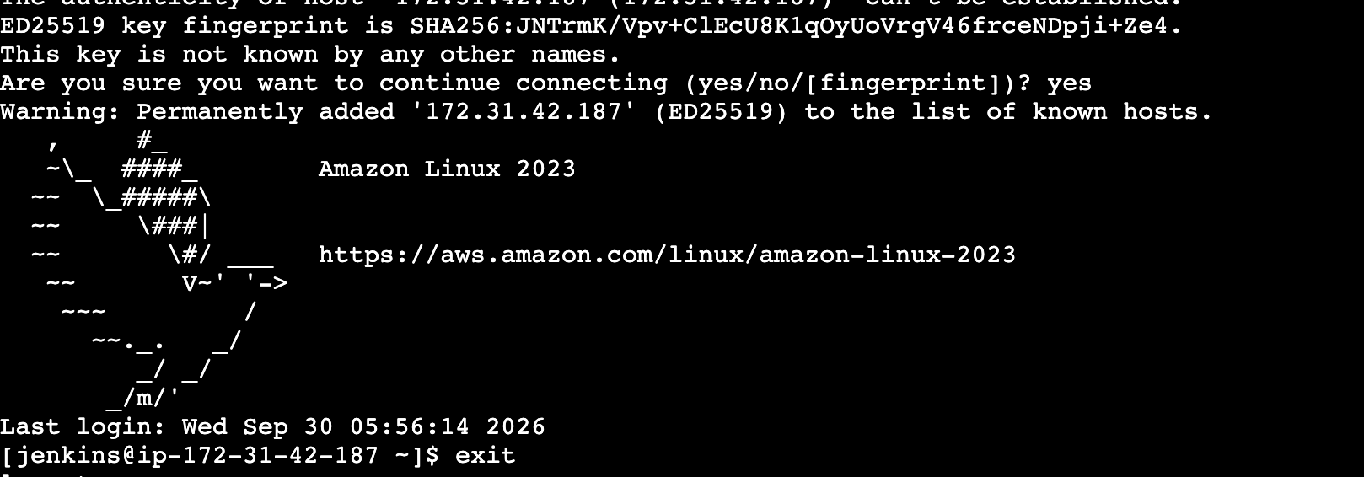
# Test connection to Slave 2:
ssh -i ~/.ssh/id_ed25519 jenkins@172-31-37-71
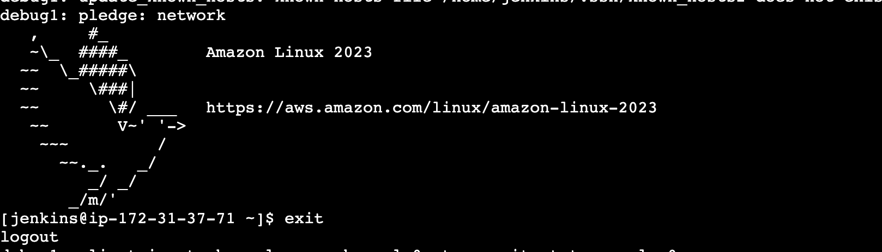
Master IPv4:8080
Open your Jenkins UI [http://54.79.190.205:8080]
Why ed25519 Keys Instead of RSA?
Modern Cryptography: ed25519 relies on the Edwards-curve Digital Signature Algorithm (EdDSA) over Curve25519, offering higher security than legacy 2048-bit or 3072-bit RSA.
Performance & Speed: Signature generation and public-key verification are significantly faster, reducing handshake latency when launching agents.

Configure webhooks to the Jenkins job.
GitHub (Login) → Settings → Webhook → Addwebhook
under Payload
http://54.79.190.205:8080/github-webhook
Which events would you like to trigger this webhook?

Just the push event.
Send me everything. ✅
Let me select individual events.
Add Webhook
How to check if the webhook has been given 200 status.
Edit → Recent Deliveries → … (Click) → 200 status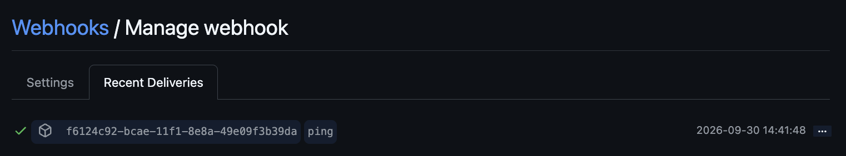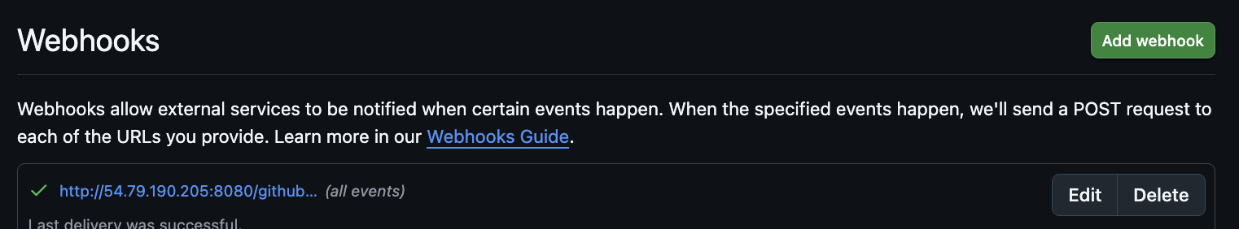
Configure Poll SCM and Build Periodically options in the Jenkins job.
Login to the Jenkins
New Item
1st_job – > Free Style
Poll SCM
*****
Git:
URL: https://github.com/sreevemurisv/Private_jenkins.git
Token password:
Save
Run the Build.
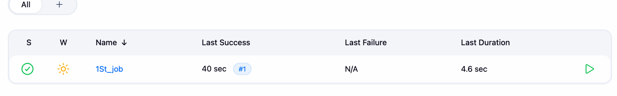
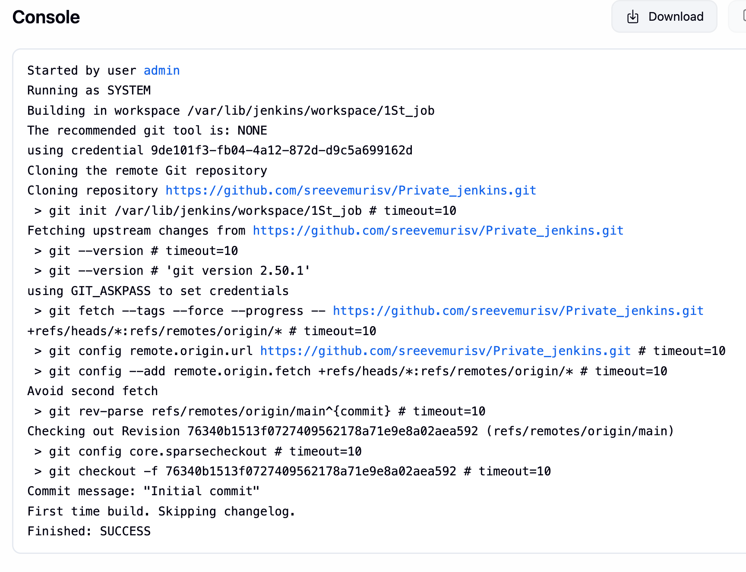
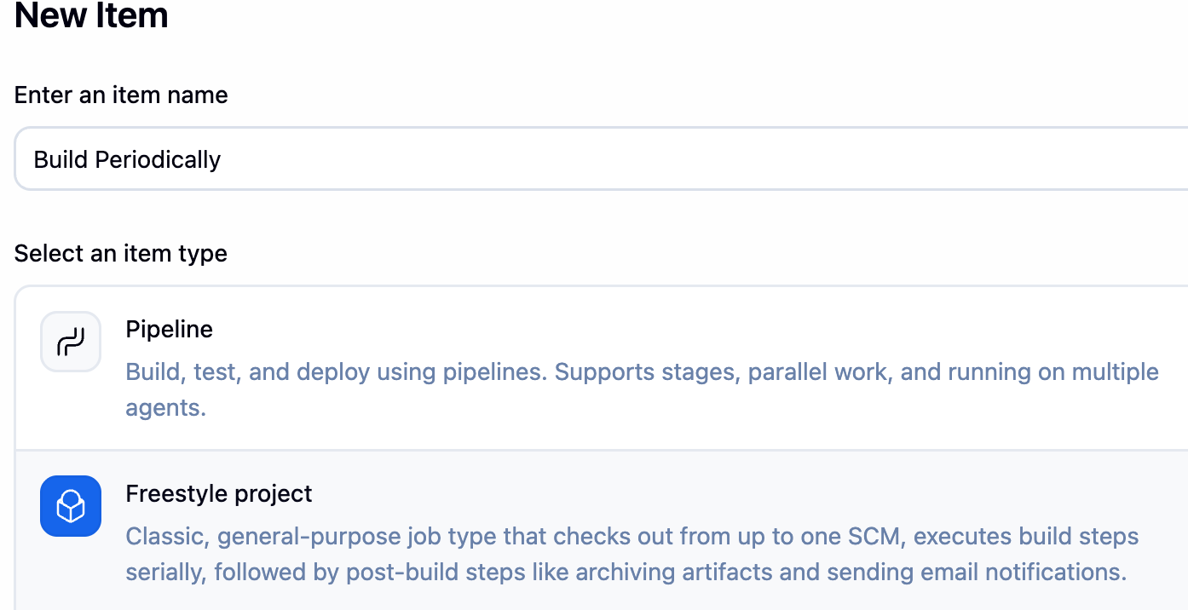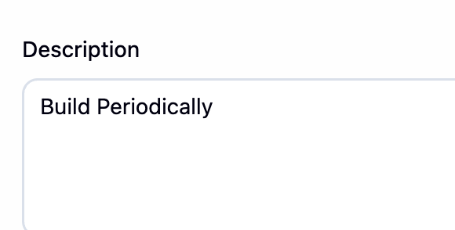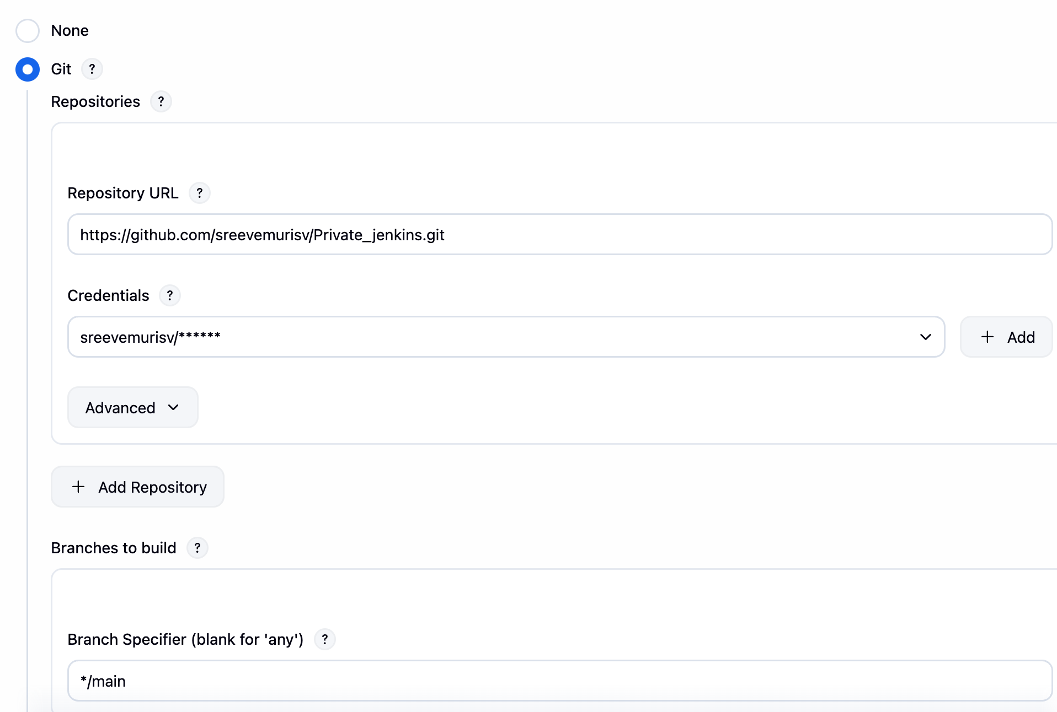

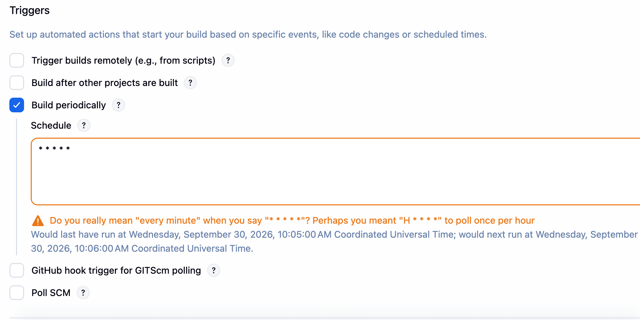
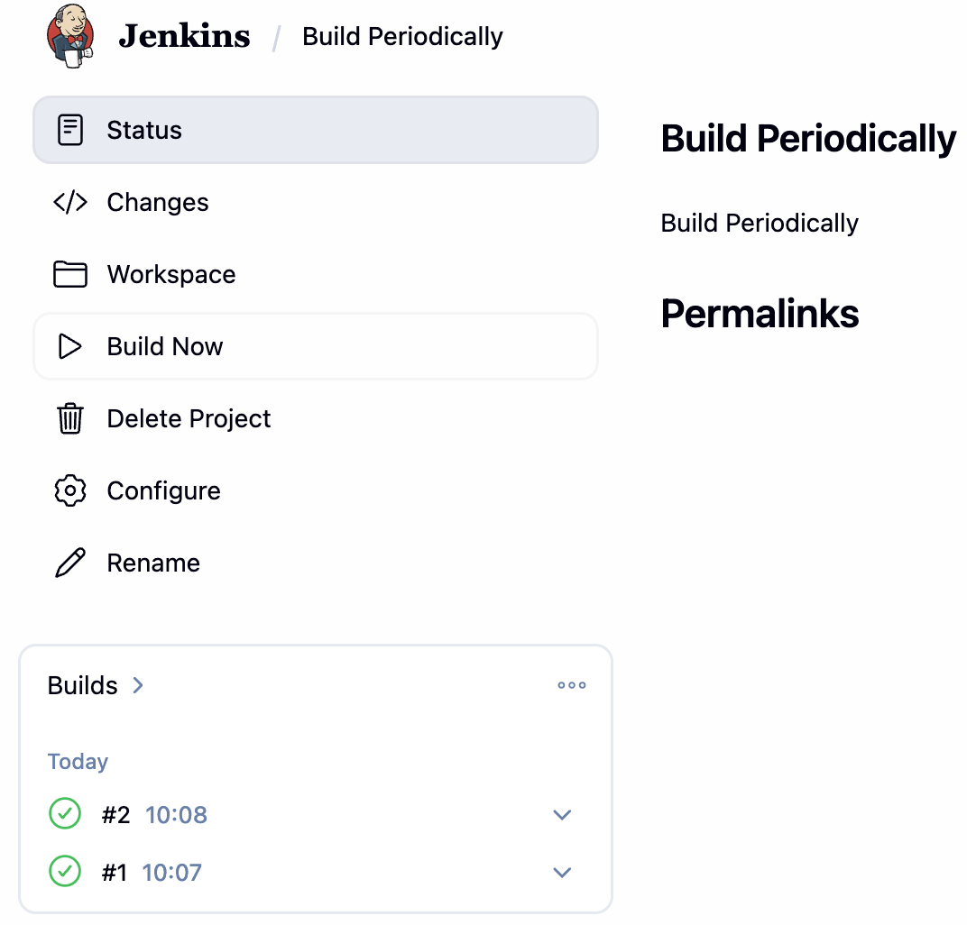
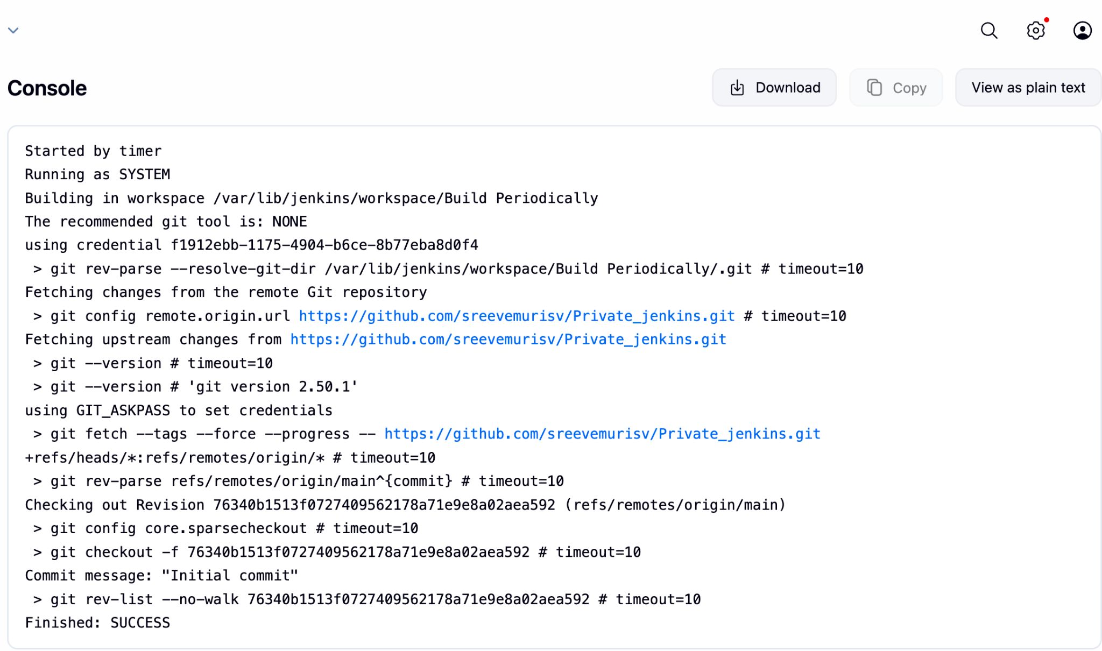
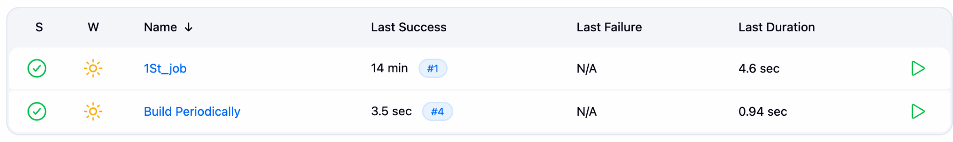
Take a backup of the Jenkins server using a bash-script.
Take a backup of Jenkins using the ThinBackup plugin.
Install the Plugin “”thinBackup”
[root@ip-172-31-34-160 ~]# mkdir -p /var/backups/jenkins_thinbackup
[root@ip-172-31-34-160 ~]# chown -R jenkins:jenkins
/var/backups/jenkins_thinbackup
[root@ip-172-31-34-160 ~]# chmod 755 /var/backups/jenkins_thinbackup
[root@ip-172-31-34-160 ~]# cd /var/backups/jenkins_thinbackup
[root@ip-172-31-34-160 jenkins_thinbackup]# pwd
/var/backups/jenkins_thinbackup
[root@ip-172-31-34-160 jenkins_thinbackup]# ll
total 16
drwxr-xr-x. 6 jenkins jenkins 16384 Sep 30 10:24 FULL-2026-09-30_10-24
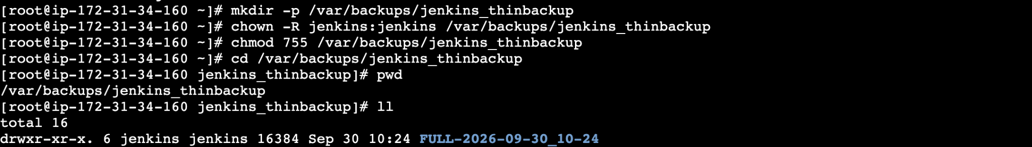
Set up a new Jenkins server and restore the backup taken in task 4.
Here from the task 4 we have took the back up from master
→ by using tar -cvf filename backup.tar
→scp -i .pem backup.tar ec2-user@16.176.166.99:/home/ec2-user
16.176.166.99 → slave-2 public IP
Note If there is any error change the .pem with new .pem
→ check the back up has gone to the selected server.
→ Now try to extract the file
→ move the backup.tar to /var/lib from /home/ec2-user
→if there is any file jenkins running remove that file and run the new file jenkins
→ rm -rf jenkins
cd /var/lib/
→cp the jenkins from the backup.tar post extract {tar xvf backup.tar /var/lib}
→ run the Jenkins in Ui to see the master jenkins jobs have coming inslave
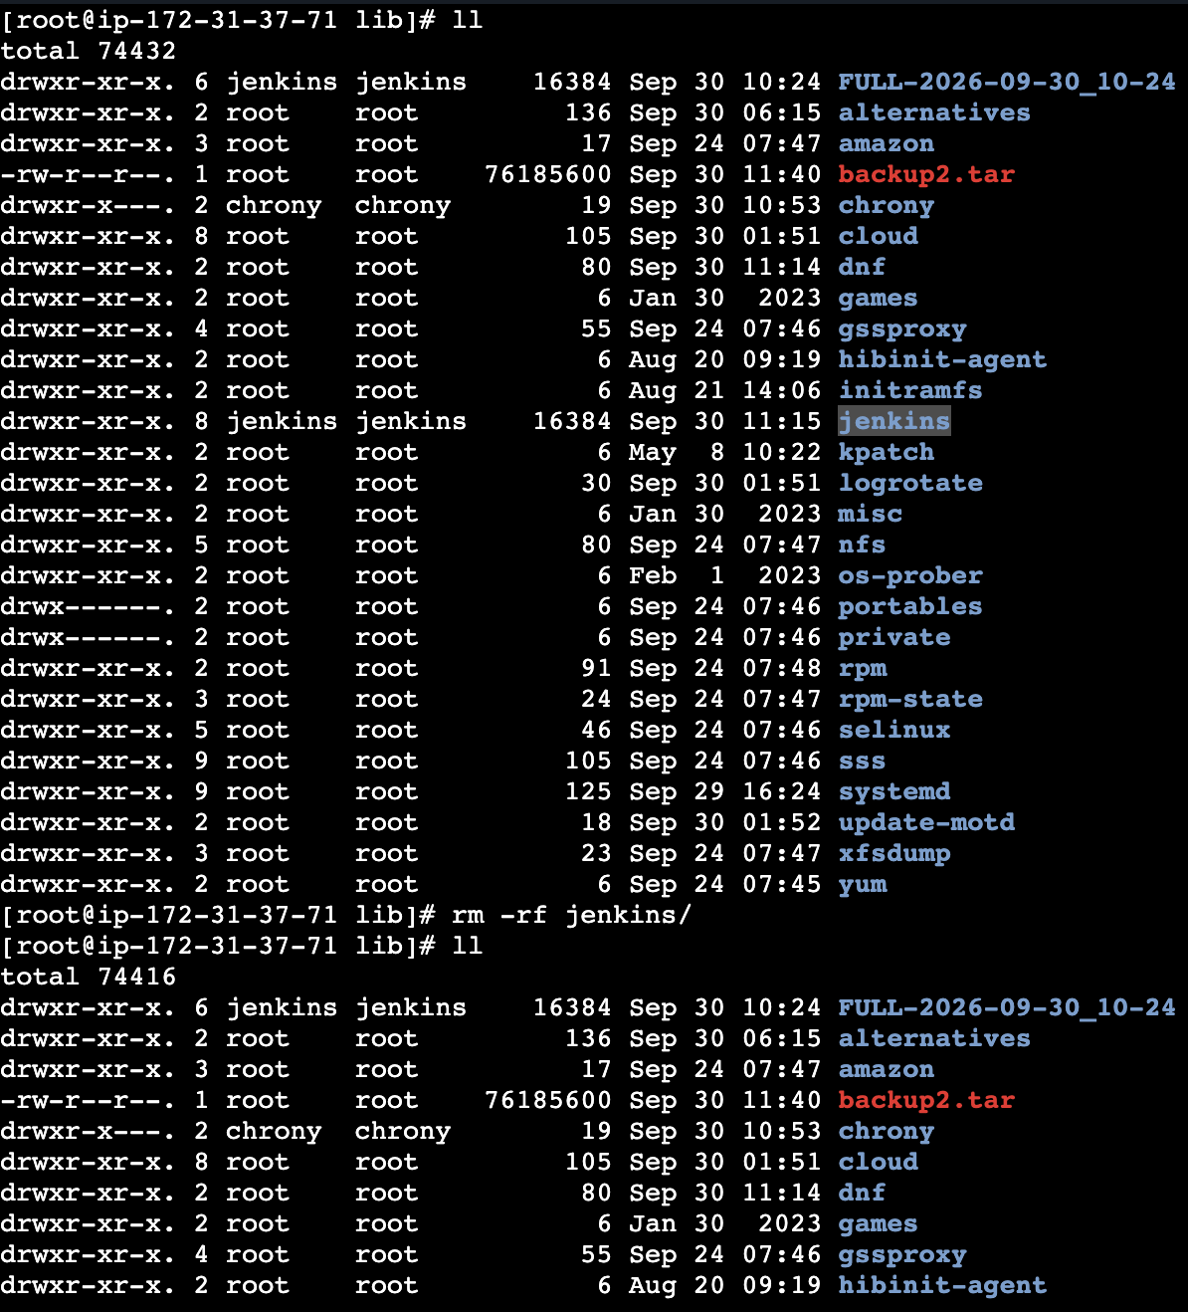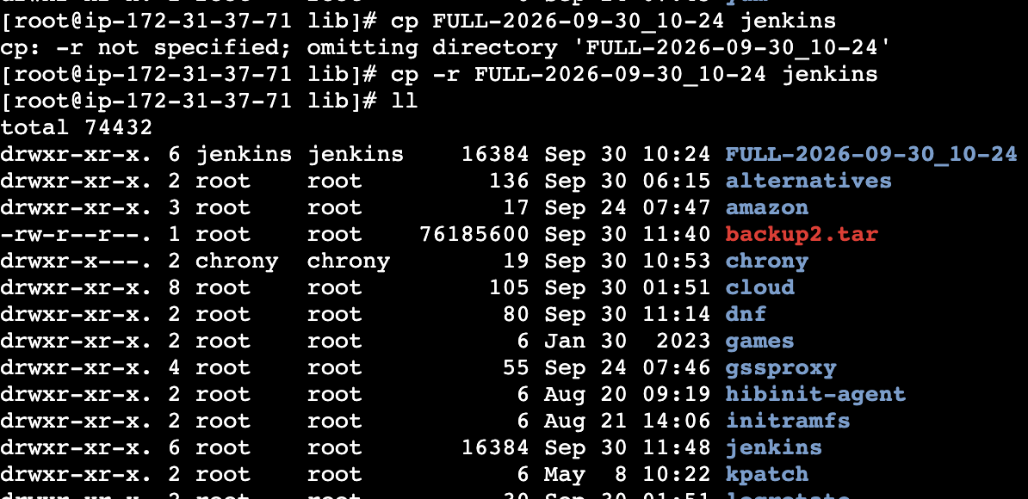
[root@ip-172-31-37-71 lib]# chmod 777 jenkins/
[root@ip-172-31-37-71 lib]# ll
vim config.xml
[root@ip-172-31-37-71 jenkins]# systemctl restart jenkins

